EXPT NO:4B | EXPLORATORY DATA ANALYSIS-DATA INSPECTION, FILTERING, STATISTICAL ANALYSIS AND CORRELATION

AIM:
To visualize the AI Impact on Jobs 2030 dataset using Python and create different charts to understand the distribution of job-related and AI-related attributes and identify important patterns in the dataset
PROCEDURE:
- Start the program.
- Import Pandas, Matplotlib, and Seaborn libraries.
- Load the AI Impact on Jobs 2030 CSV dataset.
- Display the first few records using head().
- Create a bar chart to compare the distribution of jobs based on Automation Level.
- Create a pie chart to show the distribution of jobs based on AI Tool Usage.
- Create a line chart to analyze the relationship between Years of Experience and AI Replacement Risk.
- Create a box plot to identify the distribution and possible outliers in Average Salary. Add suitable titles, axis labels, and legends.
- Display all the visualizations.
- Analyze the graphs and identify important patterns related to AI impact on jobs.
- Stop the program

CODE:

import pandas as pd
import matplotlib.pyplot as plt
import seaborn as sns

df = pd.read_csv("AI_Impact_on_Jobs_2030.csv")

print("First 5 Records")
print(df.head())

print("\nNumerical Columns:")
print(df.select_dtypes(include="number").columns.tolist())

# BAR CHART

plt.figure(figsize=(8,5))

df["Automation_Level"].value_counts().plot(kind="bar")

plt.title("Bar Chart - Automation Level")
plt.xlabel("Automation Level")
plt.ylabel("Number of Jobs")

plt.show()

# PIE CHART

plt.figure(figsize=(7,7))

df["AI_Tool_Usage"].value_counts().plot(
kind="pie",
autopct="%1.1f%%"
)

plt.title("Pie Chart - AI Tool Usage")
plt.ylabel("")

plt.show()

# LINE CHART

data = df.sort_values("Years_Experience").head(20)

plt.figure(figsize=(8,5))

plt.plot(
data["Years_Experience"],
data["AI_Replacement_Risk"],
marker="o"
)

plt.title("Line Chart - Experience vs AI Replacement Risk")
plt.xlabel("Years of Experience")
plt.ylabel("AI Replacement Risk")

plt.grid()
plt.show()
plt.figure(figsize=(8,5))

sns.boxplot(x=df["Average_Salary_USD"])

plt.title("Box Plot - Average Salary")
plt.xlabel("Average Salary (USD)")
plt.show()

OUTPUT:
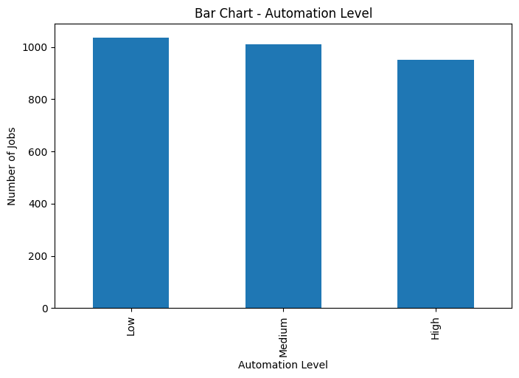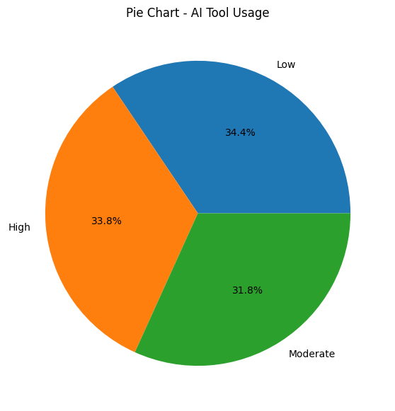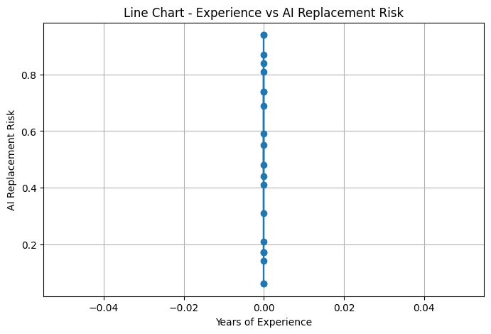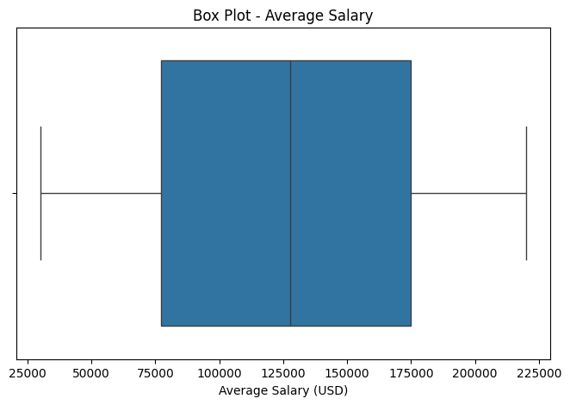

\
RESULT:
Thus, the Exploratory Data Analysis (EDA), data inspection, filtering, statistical analysis, and correlation of the AI Impact on Jobs 2030 dataset using Python data science libraries such as Pandas, Matplotlib, and Seaborn were implemented successfully, and the important patterns related to AI impact, automation, experience, salary, and AI tool usage were visualized and analyzed.

